**Air Quality Monitoring with local processing using Raspberry Pi**

Abhishek Kumar

School Of Computer Science

and Engineering

LPU, Punjab

abhishek.12010299@lpu.in

Sudip Kumar Mandal

School Of Computer Science

and Engineering

LPU, Punjab

sudip.12019167@lpu.in

Rupesh Gaur

School Of Computer Science

and Engineering

LPU, Punjab

rupesh.12001533@lpu.in

**ABSTRACT**

**Air is the element of life, if contains harmful gases could result in deteriorating our health or even worse death. So, it is really important that we should be breathing in fresh air, though that is exactly not possible when it comes to a city life. So at least what we can do is that we don’t breathe the harmful air. But how to do that exactly, air is not something we can see or even when it comes to smoke we see or smell it when its concentration rises a lot. Waiting for that moment could already result in a lot more. So, this device made using the sensors MQ7, MQ135 and DHT11 keeps an eye on the harmful gasses and environmental changes around you[1], so that you don’t have to worry about that. This device also gives you a daily update of the air quality in a graphical format through telegram bot. The processing of the data is being done locally in the raspberry pi so that even if internet is not available due to some circumstances, it should not create any problem[4].**

***Keywords: Raspberry pi, Arduino Uno, MQ7, MQ135, DHT11, Telegram bot, Local processing***

**INTRODUCTION**

With the increasing number of vehicles, industries and altogether even cities, the quality of air keeps on decreasing day by day. So, it has become crucial to keep an eye on the air that we all are breathing in[2]. Though keeping an eye on the air quality is not a full-time job for a person so that is where technology comes in. The technology which resulted in making the air quality worse is now being used to restore the air to its normal state. Though restoring the air to its normal state needs time, its not something which can be done in blink of an eye, so till that time people need to be careful regarding the air that they are breathing in[6].

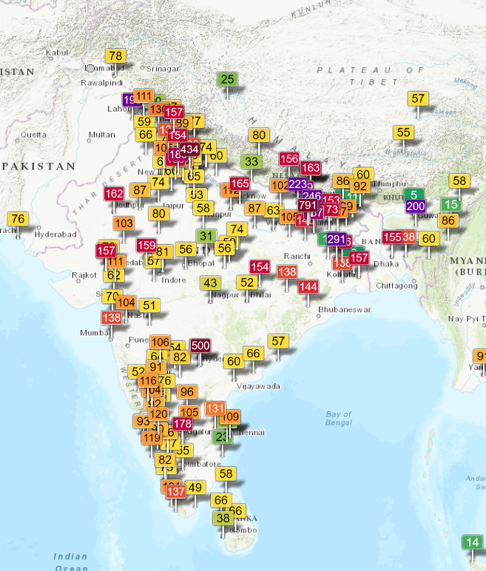

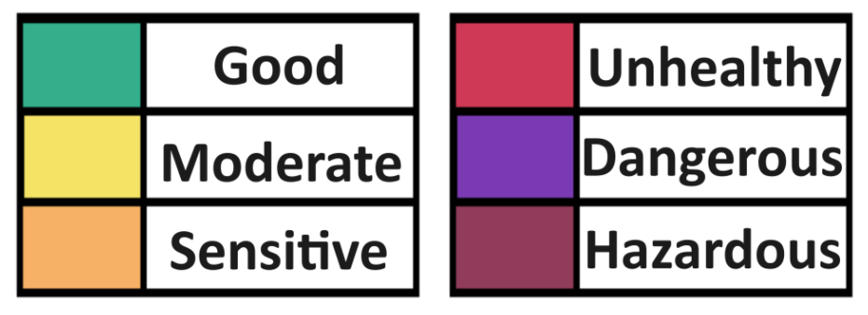

Fig1. Map of India showing air quality of various cities.

As shown in fig1, very few cities has the air quality of normal range, most of them falls in the range of moderate to sensitive and few cities like Delhi and Patna even falls in the hazardous range. Which directly means that the air that they are beathing should not even be considered as air.

Though data like these are available of various cities, but not on local level. Neither these data can tell you if suddenly air quality decreases in your house or workplace.

So, to get the data of that, a device is being proposed in this paper to detect and monitor the air quality with data being locally processed in raspberry pi[3].

This device made using RaspberryPi make use of sensors like MQ7, MQ135 and DHT11 to detect the air quality and environmental change near you and keeps you updated regarding the same. RaspberryPi does not have an ADC (Analog to Digital Converter) so, the sensors are connected using Arduino Uno and then the data is being transferred to RaspberryPi as the output data of MQ7 and MQ135 are of analog type.

So, overall this combination of RasperryPi, Arduino Uno, MQ7, MQ135 and DHT11 is your personal monitoring system of the air quality and environmental change happening around you.

**LITERATURE REVIEW**

In order to make this technology the best, few it was necessary to look into few of some previous work done in this field. Some were quite amazing while some had there limitations. This paper discuss about both the advantages and limitations of those papers, and also take valuable learning from the same.

AIR QUALITY MONITORING SYSTEM USING RASPBERRYPI[1]: Written by alumni of NIT Kurukshetra, this paper discuss about air pollution beings a problem for living organisms. This study uses RaspberryPi, Arduino Uno, MQ135, MQ9, DSMA501A dust sensor and BMP180 barometric air pressure sensor to detect the change in the environment. This study is quite good for ground ozone monitoring, though lacks when it comes to solve the problem of internet. This technology needs continuous internet connection and it is not storing and data locally either.

INDOOR AIR QUALITY CONTROLLING AND MONITORING SYSTEM BASED ON INTERNET OF THINGS[2]: Written by alumni of Master of Computer Science Bina Nusantara University, Indonesia, this paper uses MQ135 and Sharp GP2Y1010AU0F sensor to detect CO AND PM10. The advantages being using AWS cloud as a cloud platform which make retrieval of data easy for other purposes like connecting to web or app, though the use of sensors which detect only limited type of gases is the limitation of this paper.

INDOOR AIR QUALITY MONITORING ON AWS USING MQTT PROTOCOL[3]: Written by Vrushali and Dr. Rohin of VJTI, Mumbai, India, this study discuss about the usages of GP2Y20100UF dust sensor, MH-Z19 CO2 sensor and MH-Z19 NDIR infrared gas module sensor. This technology uses Node-MCU and RaspberryPi to send data to AWS Iot core and it uses MQTT protocol to connect ESP with RPi. The limitation of this paper is the lack of proper future scope and the complications of the system.

INDORE AIR QUALITY IOT BASED MONITORING SYSTEM USING RASPBERRY PI4[4]: Written by alumni of SK University, Rayalaseema University and SCERT, A.P. India, this paper uses RaspberryPi, Arduino Uno, CCS811 C02 air quality sensor and DHT11 to detect the changes in the environment, though using of ThingSpeak dashboard for graphical representation of data is a nice choice, however, lacks when it comes to process data locally. This technology needs continuous internet connection which could be a problem in case of an emergency.

NOVEL APPROACH FOR AIR QUALITY MONITORING[5]: Written by alumni of KIT, SSIT, Tiptur, India and alumni of KLEF, A.P., India, this study uses MQ2, MQ9 and PMS7003 sensor to detect the air quality of a particular place. The best part of this study is the availability of an actuator, when the air quality deteriorates, the exhaust fan tries to remove the intoxicated air. The limitation is the requirement of continuous internet connection and the unnecessary complexity of the system.

Fig2. Review Table

**COMPONENTS**

RASPBERRY PI:

Developed by Raspberry Pi Foundation, Raspberry Pi is a single board computer designed with the purpose of connecting hardware and software at one place. Mainly used in the field of IoT, this tiny computer has its own CPU, RAM, Operating System, USB ports, DHMI port for connection to screens, etc. The programming is done using micro-python, which makes it easy to connect with web applications and doing local processing.

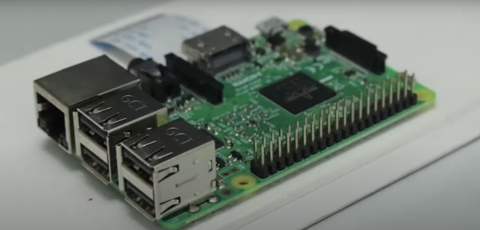

Fig3. Raspberry Pi

ARDUINO UNO:

This is a microcontroller board made to fulfil the purpose of programming devices related to Internet Of Things. This board operates on a voltage of 5V and has 6 input analog pins and 14 digital I/O pins. This board has a built in ADC converter in it. The programming of this board is done using embedded C in Arduino IDE.

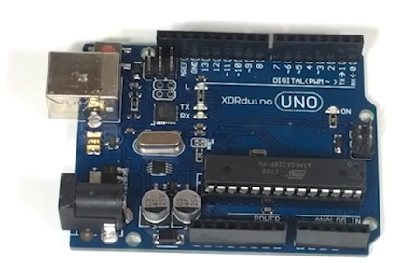

Fig4. Arduino Uno

MQ7 SENSOR:

This sensor detects the presence of Carbon Monoxide(CO) in the air. This sensor contains Tin Dioxide(SnO2) which is heated up upto 200 to 300C for the chemical reaction with CO. After the reaction the semiconductor goes oxidation, resulting in the change of conductivity of the material. Which results in wide range of output based on the concentration of Carbon Monoxide present in the air.

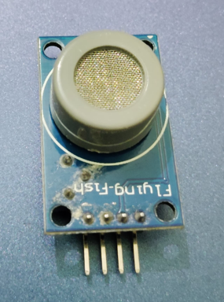

Fig5. MQ7

MQ135:

This sensor has high sensitivity with gases like ammonia, Carbon Dioxide, Sulphide, benzene series stream, smoke, etc. When the gases are detected the conductivity of the material rises ranging in the change of output analog signals. This sensor is widely used in industrial and domestic gas alarm systems.

Fig6. MQ135

DHT11:

DHT stands for Digital Humidity and Temperature. Humidity is sensed through the contraction and expansion of moisture absorbing material like polyimide, while the temperature is sensed through the change in resistance due to change in temperature in the thermistor. The DHT11 sensor gives the value of both temperature and humidity in the digital format.

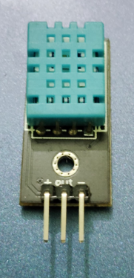

Fig7. DHT11

**WORKING**

The device uses MQ7 sensor, MQ135 sensor, DHT11 (Digital Humidity Temperature) sensor, Raspberry Pi and Arduini Uno.

As shown in Fig8 the DHT11 sensor, MQ135 sensor and MQ7 sensor are connected to the Arduino Uno as Raspberry Pi doesn’t have an ADC (Analog to Digital Converter) to take the analog input from MQ7 and MQ135.

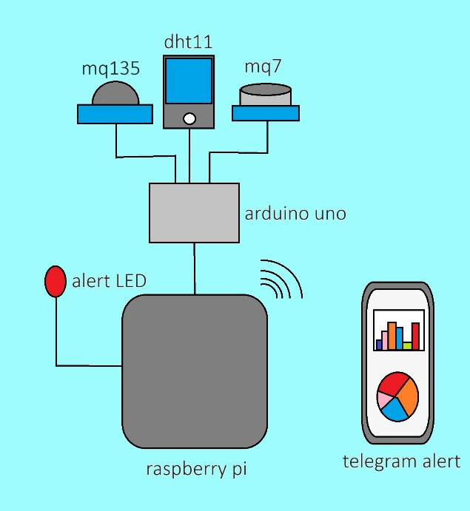

Fig 8. Working of the device

So, the Arduino Uno takes the analog input from these sensors and is transferring the digital data to the Raspberry Pi for further processing. The Raspberry Pi then takes the data and save the same in its memory for further processing. The data is being collected, processed, and stored as files on a daily basis thanks to micro python supported by Raspberry Pi.

Fig9. Flow Chat

The Flow Chat in Fig9 explains the working of and the data flow of the data collected from various sensors and the final result as the arrival of the data in the Telegram app.

**CONCLUSION**

This paper covers the making of a device using MQ7, MQ135 and DHT11 sensors to detect the variation in the air quality and also gives a user a proper representation of the data after processing. The Unique point of this paper is that this device also works when the internet is not available, as instead of processing of data on some cloud service, this device is making use of Raspberry Pi to process data in it and also stores the data. So, when the internet connection will be restored, the data can be transmitted to the authorised user.

This paper is a step in the right direction for improving the quality of live of people by making them realise about the air that they are breathing in.

**FUTURE SCOPE**

This device when worked with other device can act as various individual system which can be activated as a result of data sent from this device. Few of the notable use of this device are like turning on an alarm system when air quality deteriorates or turning on air purifier. The other uses of this device can be in the field of research when data needs to be collected on regular basis to check the working of air purifying device or plants.

When used at large scale various home automation systems like the working of exhaust or the sprinkling of water, can be actuated based on the data provided by this device.

**REFRENCES**

[1] S. Kumar and A. Jasuja, "Air quality monitoring system based on IoT using Raspberry Pi," 2017 International Conference on Computing, Communication and Automation (ICCCA), Greater Noida, India, 2017

[2] F. Pradityo and N. Surantha, "Indoor Air Quality Monitoring and Controlling System based on IoT and Fuzzy Logic," 2019 7th International Conference on Information and Communication Technology (ICoICT), Kuala Lumpur, Malaysia, 2019

[3] V. Ladekar and R. Daruwala, "Indoor Air Quality Monitoring on AWS Using MQTT Protocol," 2019 10th International Conference on Computing, Communication and Networking Technologies (ICCCNT), Kanpur, India, 2019

[4] S. Faiazuddin, M. V. Lakshmaiah, K. T. Alam and M. Ravikiran, "IoT based Indoor Air Quality Monitoring system using Raspberry Pi4," 2020 4th International Conference on Electronics, Communication and Aerospace Technology (ICECA), Coimbatore, India, 2020

[5] T. Wang et al., "A Novel Approach to Air Quality Monitoring: Towards Miniature, Self-organized, and Low-power Device," 2023 IEEE SENSORS, Vienna, Austria, 2023

[6] Y. Munsadwala, P. Joshi, P. Patel and K. Rana, "Identification and Visualization of Hazardous Gases Using IoT," 2019 4th International Conference on Internet of Things: Smart Innovation and Usages (IoT-SIU), Ghaziabad, India, 2019

[7] S. I. Nahid and M. M. Khan, "Toxic Gas Sensor and Temperature Monitoring in Industries using Internet of Things (IoT)," 2021 24th International Conference on Computer and Information Technology (ICCIT), Dhaka, Bangladesh, 2021

[8] S. Z. Yahaya, M. N. Mohd Zailani, Z. H. Che Soh and K. A. Ahmad, "IoT Based System for Monitoring and Control of Gas Leaking," 2020 1st International Conference on Information Technology, Advanced Mechanical and Electrical Engineering (ICITAMEE), Yogyakarta, Indonesia, 2020

[9] M. F. Mohd Pu'ad, T. S. Gunawan, M. Kartiwi and Z. Janin, "Development of Air Quality Measurement System using Raspberry Pi," 2018 IEEE 5th International Conference on Smart Instrumentation, Measurement and Application (ICSIMA), Songkhla, Thailand, 2018